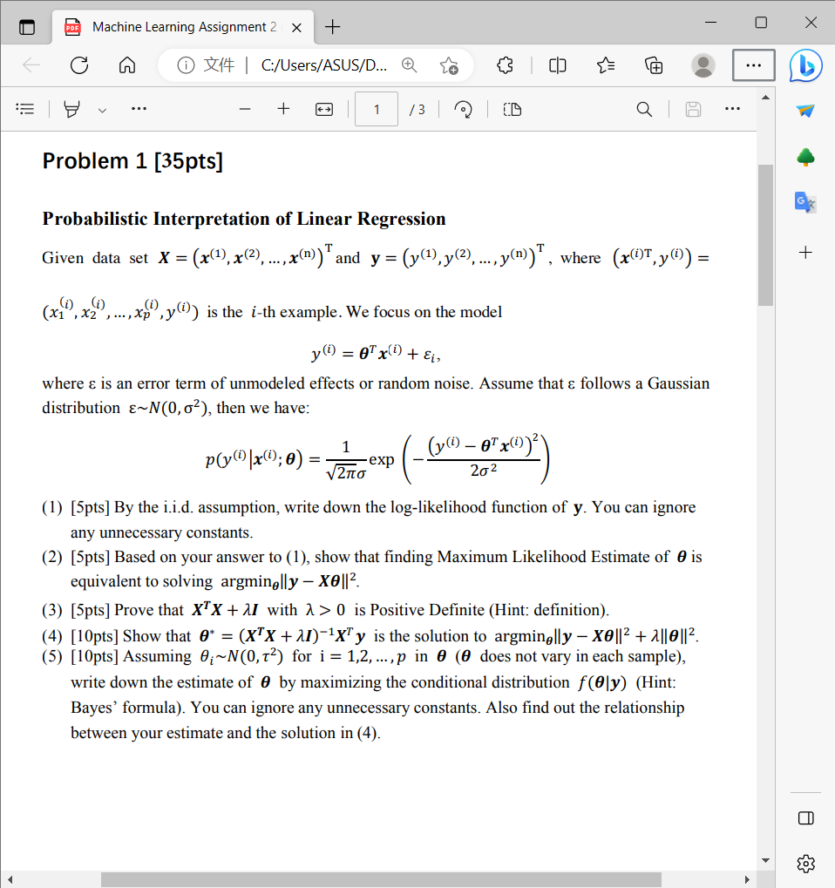

1. The log-likelihood function of $y$ is:
$$\ln{l\left(θ\right)}=\sum_{i=1}^{n}{ln⁡(p(y^{\left(i\right)}|x^{\left(i\right)};θ))}=-\frac{1}{2σ^{2}}\sum_{i=1}^{n}{{\left(y^{\left(i\right)}-θ^{T}x^{\left(i\right)}\right)}^{2}}-n\ln{\sqrt{2π}σ}$$

2. After ignoring all of the unnecessary constants, the Maximum Likelihood Estimate of $θ$ is $\hat{θ}=\arg{\min{\sum_{i=1}^{n}{{\left(y^{\left(i\right)}-θ^{T}x^{\left(i\right)}\right)}^{2}}}}$, then

$$\sum_{i=1}^{n}{{\left(y^{\left(i\right)}-θ^{T}x^{\left(i\right)}\right)}^{2}}=\left[y^{\left(1\right)}-θ^{T}x^{\left(1\right)}⋯ y^{\left(n\right)}-θ^{T}x^{\left(n\right)}\right]\left[\begin{aligned}y^{\left(1\right)}-θ^{T}x^{\left(1\right)} \\ ⋮ \\ y^{\left(n\right)}-θ^{T}x^{\left(n\right)}\end{aligned}\right]$$

where

$$\left[\begin{aligned}y^{\left(1\right)}-θ^{T}x^{\left(1\right)} \\ ⋮ \\ y^{\left(n\right)}-θ^{T}x^{\left(n\right)}\end{aligned}\right]=\left[\begin{aligned}y^{\left(1\right)} \\ ⋮ \\ y^{n}\end{aligned}\right]-θ^{T}\left[x^{\left(1\right)}⋯x^{\left(n\right)}\right]=y-Xθ$$

Therefore,

$$\sum_{i=1}^{n}{{\left(y^{\left(i\right)}-θ^{T}x^{\left(i\right)}\right)}^{2}}={\left(y-Xθ\right)}^{T}\left(y-Xθ\right)={\left\|y-Xθ\right\|}^{2}$$

In conclusion, finding MLE of $θ$ is equivalent to solving $\arg{\min_{θ}{{\left\|y-Xθ\right\|}^{2}}}$.

1. Let $v$ be a non-zero vector, we have

$$v^{T}{(X}^{T}X+λI)v=v^{T}X^{T}Xv+v^{T}λIv={\left\|Xv\right\|}^{2}+λ{\left\|v\right\|}^{2}$$

Moreover, $λ>0$, hence ${\left\|Xv\right\|}^{2}+λ{\left\|v\right\|}^{2}>0$, which implies that $X^{T}X+λI$ is positive definite.

1. First simplify the objective function,

$$F\left(θ\right)={\left\|y-Xθ\right\|}^{2}+λ{\left\|θ\right\|}^{2} \\ ={\left(y-Xθ\right)}^{T}\left(y-Xθ\right)+λθ^{T}θ \\ =y^{T}y-y^{T}Xθ-θ^{T}X^{T}y+θ^{T}X^{T}Xθ+λθ^{T}θ$$

Then, find the partial derivative with respect to $θ$ and set it equal to 0.

$$\frac{∂F\left(θ\right)}{∂θ}=2X^{T}Xθ-2X^{T}y+2λIθ=0$$

Solve this equation, we can get $θ^{*}={\left(X^{T}X+λI\right)}^{-1}X^{T}y$

Then find the second order partial derivative with respect to $θ$

$$\frac{∂^{2}F\left(θ\right)}{∂θ^{2}}=2\left(X^{T}X+λI\right)>0$$

Therefore, $θ^{*}$ is the solution of $\arg{\min{{\left\|y-Xθ\right\|}^{2}+λ{\left\|θ\right\|}^{2}}}$

1. According to Bayes’ formula

$$f\left(θ | y\right)=\frac{f(θ)f(y|θ)}{f(y)}$$

Write the distribution of $θ_{i}$ in vector form

$$f\left(θ\right)=\frac{1}{\sqrt{{\left(2π\right)}^{n}\left|Σ\right|}}\exp\left(-\frac{1}{2}θ^{T}Σ^{-1}θ\right), where Σ=\left[\begin{matrix}τ^{2} & 0 & ⋯ & 0 \\ 0 & τ^{2} & ⋯ & 0 \\ ⋮ & ⋮ & ⋱ & ⋮ \\ 0 & 0 & ⋯ & τ^{2}\end{matrix}\right]=τ^{2}I$$

Then

$$f\left(θ | y\right)∝f\left(θ\right)f\left(y | θ\right) \\ ∝\exp\left(-\frac{{\left\|θ\right\|}^{2}}{2τ^{2}}\right)\exp\left(-\frac{{\left(y^{\left(i\right)}-θ^{T}x^{\left(i\right)}\right)}^{2}}{2σ^{2}}\right)$$

Let $l_{0}(θ)$ be the log-likelihood function of $f\left(θ | y\right)$, and logarithmization

$$\ln{l_{0}(θ)}∝\frac{{\left\|y-Xθ\right\|}^{2}}{2σ^{2}}+\frac{{\left\|θ\right\|}^{2}}{2τ^{2}}$$

Find the partial derivative with respect to $θ$ and set it equal to 0, solve the equation, we get

$$\hat{θ}={\left(X^{T}X+\frac{σ^{2}}{τ^{2}}I\right)}^{-1}X^{T}y$$

Compare with the solution in (4), we find that $\hat{θ}$ is equal to $θ^{*}$ when $λ=\frac{σ^{2}}{τ^{2}}$.

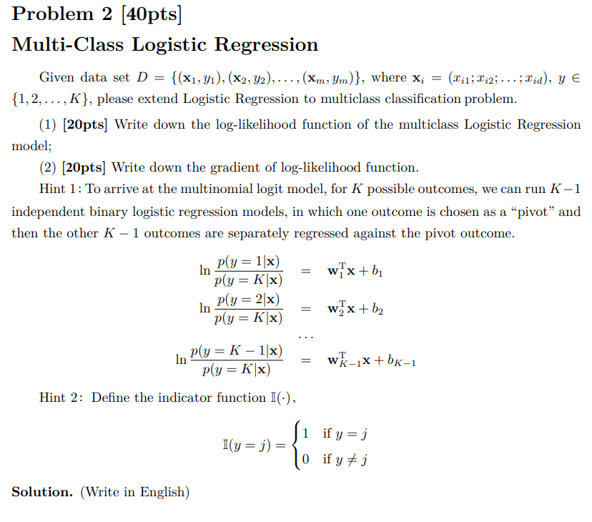

1. Let’s start from logistic function $y=1/(1+e^{-z})$, where $z = w_{k}^{T}x+b_{k}, k=1,…,K$. After logarithmization, we can get

$$\ln{\frac{y}{1-y}}=w_{k}^{T}x+b_{k}$$

According to the Hint 1, we can run $K-1$ independent binary logistic regression models, in which one output is chosen as a main category and other $K-1$ outputs are separately regressed against the main category.

Treat $y$ in the formula as a class posterior probability estimate $P\left(y=j | x\right), j=1,…, K-1$, and then rewrite the above formula to get

$$\ln{\frac{P\left(y=j | x\right)}{P\left(y=K | x\right)}}=w_{j}^{T}x+b_{j}⇒ P\left(y=j | x\right)=P\left(y=K | x\right)e^{w_{j}^{T}x+b_{j}}$$

For all categories, we have $\sum_{k=1}^{K}{P\left(y=k | x\right)}=1$, hence

$$P\left(y=K | x\right)=1-\sum_{n=1}^{K-1}{P\left(y=K | x\right)e^{w_{n}^{T}x+b_{n}}}=\frac{1}{1+\sum_{n=1}^{K-1}{e^{w_{n}^{T}x+b_{n}}}}$$

Next, only need to substitute $P\left(y=K | x\right)$ into $P\left(y=j | x\right)$, then we can calculate all the probabilities $P\left(y=k | x\right)$.

Finally, the log-likelihood function of multiclass logistic regression model is

$$\ln{l(w_{k},b_{k})}=\sum_{i=1}^{m}{\ln{p(y_{i}|x_{i};w_{k},b_{k})}}$$

Let $β_{k}=\left(w_{k};b_{k}\right), \hat{x}=\left(x;1\right)$, then $w_{k}^{T}x+b_{k}$ can be written as $β_{k}^{T}\hat{x}$ in short. And let $p_{k}\left(\hat{x};β_{k}\right)=p(y=k|\hat{x};β_{k})$, then likelihood term in $\ln{l(w,b)}$ can be rewritten as

$$p\left(y_{i} | x_{i};w_{k},b_{k}\right)=I\left(y_{i}=k\right)p_{k}\left({\hat{x}}_{i};β_{k}\right) \\ =I\left(y_{i}=j\right)p_{j}\left({\hat{x}}_{i};β_{k}\right)+I\left(y_{i}=K\right)p_{K}\left({\hat{x}}_{i};β_{k}\right) \\ = I\left(y_{i}=j\right)\frac{e^{β_{j}{\hat{x}}_{i}}}{1+\sum_{n=1}^{K-1}{e^{β_{n}{\hat{x}}_{i}}}}+I\left(y_{i}=K\right)\frac{1}{1+\sum_{n=1}^{K-1}{e^{β_{n}{\hat{x}}_{i}}}}$$

Finally, we can obtain

$$\ln{l(β_{k})}=\sum_{i=1}^{m}{\sum_{j=1}^{K-1}{I(y_{i}=j)β_{j}^{T}{\hat{x}}_{i}}-\ln\left(1+\sum_{n=1}^{K-1}{e^{β_{n}^{T}{\hat{x}}_{i}}}\right)}$$

1. The gradient of log-likelihood function is

$$\frac{∂\ln{l\left(β_{k}\right)}}{∂β_{k}}=\left\{\begin{aligned}\sum_{i=1}^{m}{I\left(y_{i}=k\right){\hat{x}}_{i}-\frac{{{\hat{x}}_{i}e}^{β_{k}^{T}{\hat{x}}_{i}}}{1+\sum_{n=1}^{K-1}{e^{β_{n}^{T}{\hat{x}}_{i}}}}} \\ 0, k&=K\end{aligned}, k=1,…,K-1\right.$$

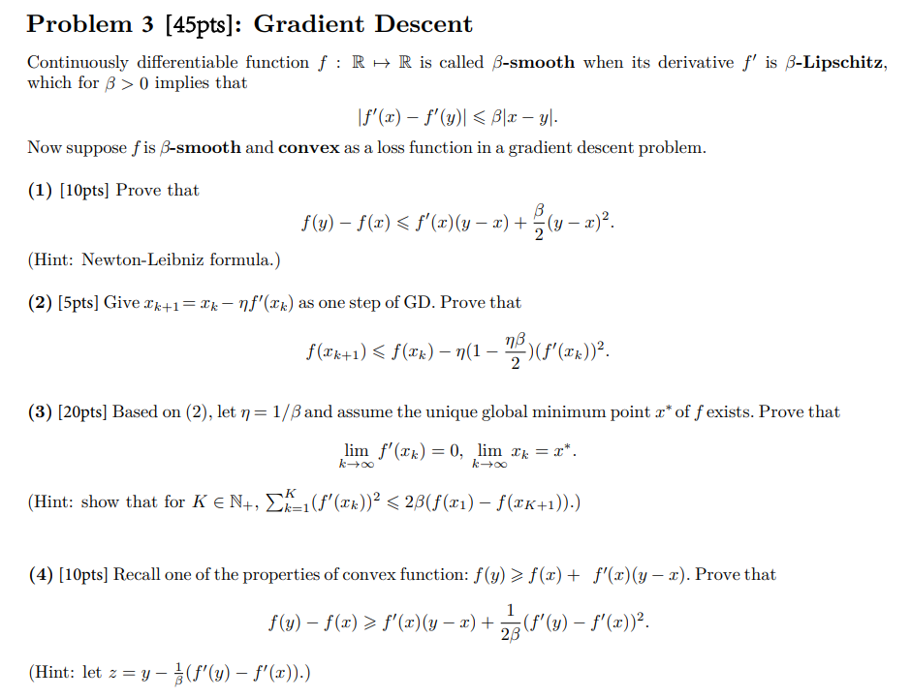

1. From the Newton-Leibniz formula, it is apparent that

$$f\left(y\right)-f\left(x\right)=\int_{0}^{1}{f'\left(x+t\left(y-x\right)\right)(y-x)dt}$$

Then by the property of convex function and *β*-smoothness

$$f\left(y\right)-f\left(x\right)-f^{'}\left(x\right)\left(y-x\right)=\int_{0}^{1}{\left(f^{'}\left(x+t\left(y-x\right)\right)-f^{'}\left(x\right)\right)\left(y-x\right)dt} \\ ≤\left|\int_{0}^{1}{\left(f^{'}\left(x+t\left(y-x\right)\right)-f^{'}\left(x\right)\right)\left(y-x\right)dt}\right| \\ ≤\int_{0}^{1}{\left|f^{'}\left(x+t\left(y-x\right)\right)-f^{'}\left(x\right)\right|\left|y-x\right|dt} \\ ≤\int_{0}^{1}{β\left|t\left(y-x\right)\right|\left|y-x\right|dt} \\ =\frac{β}{2}{\left(y-x\right)}^{2}$$

$$⇒f\left(y\right)-f\left(x\right)≤f^{'}\left(x\right)\left(y-x\right)+\frac{β}{2}{\left(y-x\right)}^{2}$$

1. Based on (1)
$$f\left(x_{k+1}\right)-f\left(x_{k}\right)≤f^{'}\left(x_{k}\right)\left(x_{k+1}-x_{k}\right)+\frac{β}{2}{\left(x_{k+1}-x_{k}\right)}^{2} \\ =-η{\left(f^{'}\left(x_{k}\right)\right)}^{2}+\frac{β}{2}η^{2}{\left(f^{'}\left(x_{k}\right)\right)}^{2} \\ =-η(1-\frac{ηβ}{2}){\left(f^{'}\left(x_{k}\right)\right)}^{2}$$

$$⇒ f\left(x_{k+1}\right)≤f\left(x_{k}\right)-η(1-\frac{ηβ}{2}){\left(f^{'}\left(x_{k}\right)\right)}^{2}$$

2. Based on (2), let $η=1/β$, we have

$${\left(f^{'}\left(x_{k}\right)\right)}^{2}≤2β\left(f\left(x_{k}\right)-f\left(x_{k+1}\right)\right) \\ \sum_{k=1}^{K}{{\left(f^{'}\left(x_{k}\right)\right)}^{2}}≤2β\left(f\left(x_{k}\right)-f\left(x_{k+1}\right)+⋯+f\left(x_{1}\right)-f\left(x_{2}\right)\right) \\ =2β(f\left(x_{1}\right)-f\left(x_{K+1}\right))$$

$\sum_{k=1}^{K}{{\left(f^{'}\left(x_{k}\right)\right)}^{2}}$ is converge, hence $\lim_{k→∞}{{\left(f^{'}\left(x_{k}\right)\right)}^{2}}=\lim_{k→∞}{f^{'}\left(x_{k}\right)}=0$.

Next, we can prove $\lim_{k→∞}{x_{k}=x^{*}}$ by contradiction. Assume that $\lim_{k→∞}{x_{k}≠x^{*}}$, which means

$$∃δ>0,∀N∈N_{+}, ∃m>N,\left|x_{m}-x^{*}\right|≥δ$$

From $\lim_{k→∞}{f^{'}\left(x_{k}\right)}=0$, we know

$$∀ϵ>0,∃N^{'}∈N_{+},∀n>N^{'},\left|f^{'}\left(x_{n}\right)\right|<ϵ$$

Note that $x^{*}$ is the unique global minimum point and $f'(x)$ is monotony, hence take $x_{1}∈(x^{*} -δ,x^{*})$ and $x_{2}∈(x^{*},x^{*}+δ)$, we get $f^{'}\left(x_{1}\right)<f^{'}\left(x^{*}\right)=0<f'(x_{2})$. Let $ϵ_{0}=\frac{1}{2}\min{\{\left|f^{'}\left(x_{1}\right)\right|, \left|f^{'}\left(x_{2}\right)\right|\}}$, $∃N=N_{0}, ∀m>N_{0}, \left|f^{'}\left(x_{m}\right)\right|<ϵ_{0}$. However, for the same $N=N_{0}$,there should be $∃m>N,\left|x_{m}-x^{*}\right|≥δ$, which means $\left|f'(x_{m})\right|≥\min\left\{\left|f^{'}\left(x_{1}\right)\right|, \left|f^{'}\left(x_{2}\right)\right|\right\}=2ϵ_{0}$. This is contradictory. In conclusion, $\lim_{k→∞}{x_{k}=x^{*}}$.

1. Let $z=y-\frac{1}{β}\left(f^{'}\left(y\right)-f^{'}\left(x\right)\right)$, based on (1), we have

$$f\left(z\right)-f\left(y\right)≤f^{'}\left(y\right)\left(z-y\right)+\frac{β}{2}{\left(y-z\right)}^{2}$$

Therefore,

$$f\left(y\right)-f\left(z\right)≥f^{'}\left(y\right)\left(y-z\right)-\frac{β}{2}{\left(y-z\right)}^{2}=\frac{1}{β}f^{'}\left(y\right)\left(f^{'}\left(y\right)-f^{'}\left(x\right)\right)-\frac{β}{2}{\left(y-z\right)}^{2}$$

From the property of convex function

$$f\left(z\right)-f\left(x\right)≥f^{'}\left(x\right)\left(z-x\right)=f^{'}\left(x\right)\left(y-x\right)+\frac{1}{β}f^{'}\left(x\right)\left(f^{'}\left(x\right)-f^{'}\left(y\right)\right)$$

Add the above two formulas together

$$f\left(y\right)-f\left(x\right)≥f^{'}\left(x\right)\left(y-x\right)+\frac{1}{β}{\left(f^{'}\left(y\right)-f^{'}\left(x\right)\right)}^{2}-\frac{β}{2}{\left(y-z\right)}^{2} \\ =f^{'}\left(x\right)\left(y-x\right)+\frac{1}{β}{\left(f^{'}\left(y\right)-f^{'}\left(x\right)\right)}^{2}-\frac{1}{2β}{\left(f^{'}\left(y\right)-f^{'}\left(x\right)\right)}^{2} \\ =f^{'}\left(x\right)\left(y-x\right)+\frac{1}{2β}{\left(f^{'}\left(y\right)-f^{'}\left(x\right)\right)}^{2}$$